TEST SUMMARY REPORT

CONTENTS

1.Purpose...............................................................................................................2

2.Application Overview..........................................................................................2

3. Reference Documents ...................................................................................... 2

4. Target Audience .................................................................................................2

5. Testing Scope ……………………................................................................................2

6. Metrics ................................................................................................................3

7. Types of Testing Performed................................................................................ 6

8. Test Environment and Tools................................................................................7

9. Exit Criteria ……………………………………………….........................................................7

10. Conclusion ……………………………………………………………………………………………….…...7

1. PURPOSE

This document explains the various activities performed as part of Testing of ‘Urban Ladder’ application.

2. APPLICATION OVERVIEW

“Urban Ladder” is a web-based application for online shopping of all types of furniture. It allows the user to buy all the varieties of furniture along with different types of décor items and helps to track their orders so that the user is aware of each and every detail about the delivery of order. It also allows user to send cards on special occasion. There are several modules like login, track orders, help, gift cards, bulk orders, add to cart, Wishlist, payment etc. which are integrated to fulfil the purpose.

3. REFERENCE DOCUMENTS

Test plan, Test case and Test scenarios documents

4. TARGET AUIDENCE

Project Manager, Release Team, Maintenance Team, Customer (End Users) and Client

5. TESTING SCOPE

**a) In Scope**

* Login, Sign up
* Add to cart and Wishlist, view cart
* Track Orders
* Help
* Gift cards
* Bulk orders
* Payment
* Stores
* Search box

**b) Out of Scope**

Performance Testing was not done for this application.

6. METRICS

|  |  |  |  |
| --- | --- | --- | --- |
| Test Cases Planned | Test Cases Executed | Test Cases Passed | Test Cases Failed |
| 10 | 10 | 8 | 2 |

Test Cases Passed Vs Test Cases Failed

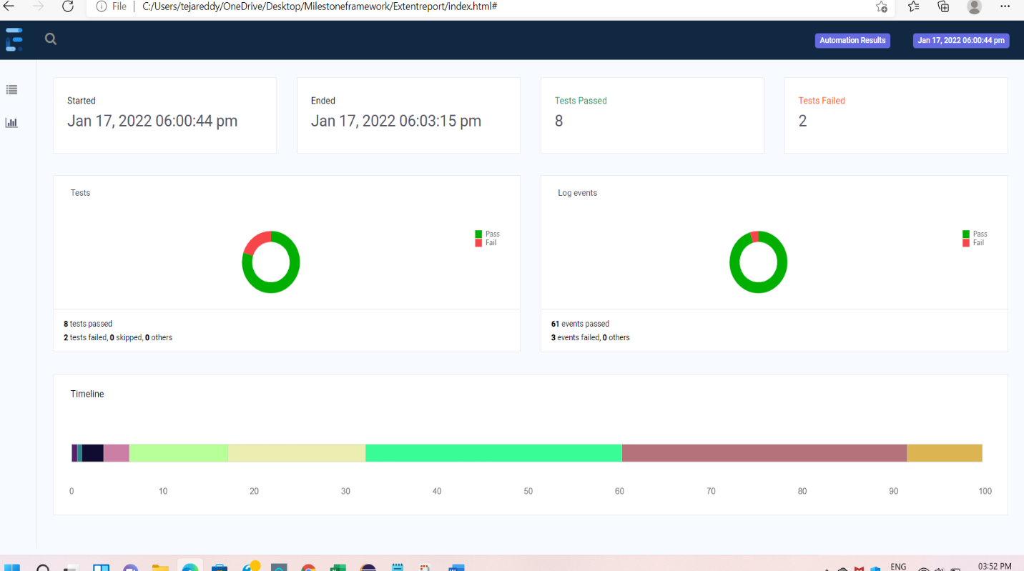

Details of Passed and Failed Testcases

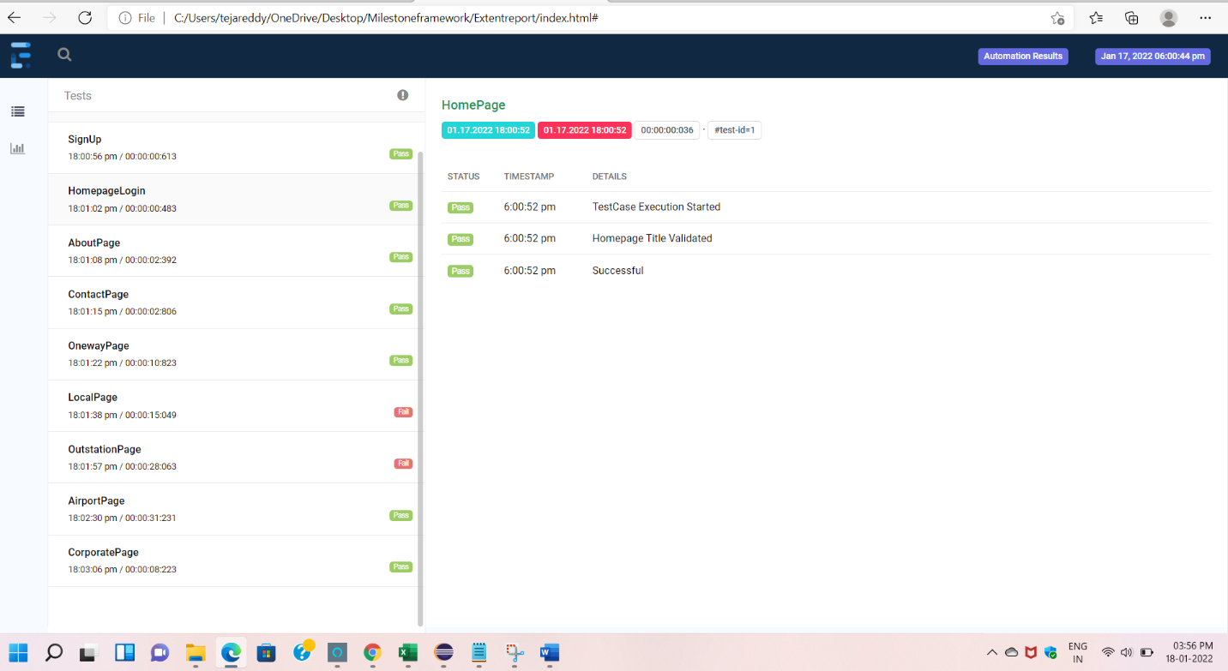

Passed TestCases

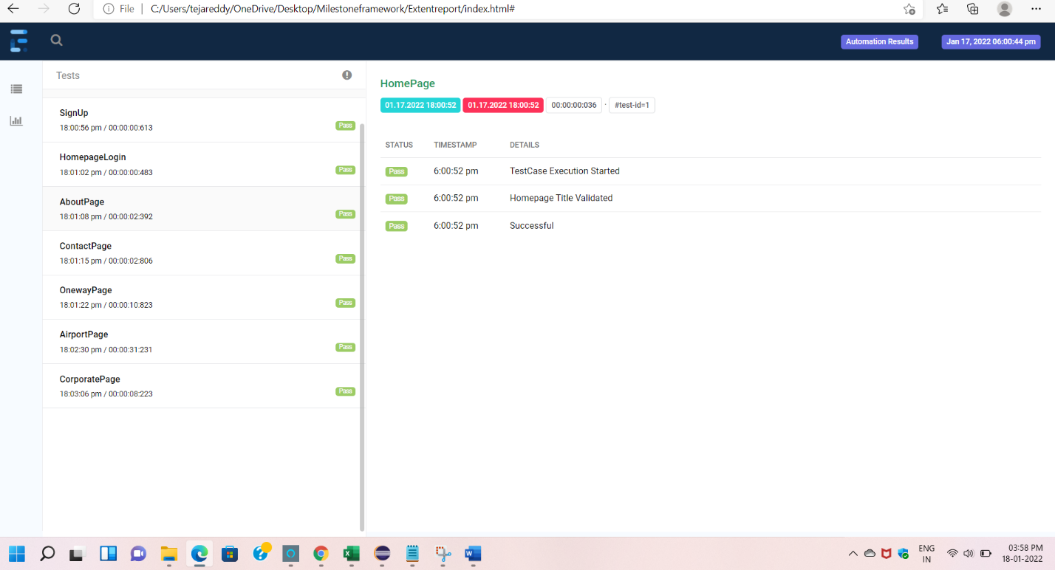

Failed TestCases

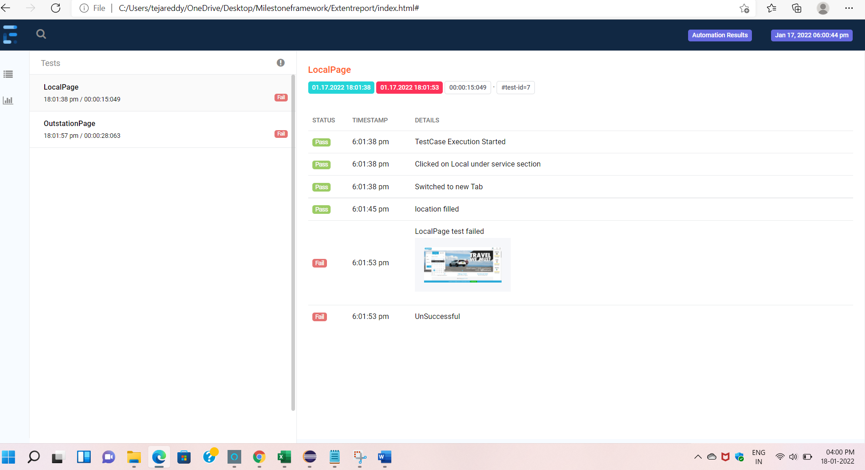

7. TYPES OF TESTING PERFORMED

**a) System Integration Testing :** This testing is performed on the application under test i.e. Urban Ladder website to verify that the entire application works as per requirement. All the possible scenarios were tested to make sure important functionalities in the application works as intended without any errors.

**b) Regression Testing** : This testing is performed each time a new build is deployed for testing which contains defect fixes. This testing ensures that existing functionalities works fine after defect fix and new enhancements are added to the existing application. Test cases for new functionalities are added to the existing test cases and executed.

8. TEST ENVIRONMENT AND TOOLS

|  |  |
| --- | --- |
| Application URL | https://www.savaari.com/ |
| Computer | Windows 11 Operating System, 8GB Ram |
| Testing tool | Selenium, Eclipse |
| Browsers | Chrome 96.0.4664.45 |

9. EXIT CRITERIA

a) All test cases should be executed - yes

b) All defects in Critical, Major, Medium severity should be verified and closed - yes

c) Most of the testcases must be passed - yes

10. CONCLUSION

As the Exit criteria was met and satisfied as mentioned in Section 9, this application is suggested to ‘Go Live’ by the Testing team. Appropriate User, Client/Business acceptance testing should be performed before ‘Go Live’.